**1 - 8.4 & 8.5**

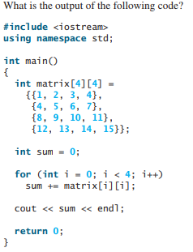

Output:  
31

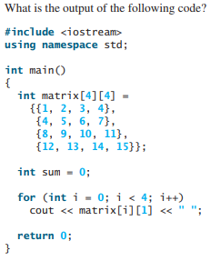

Output:  
2 5 9 13

**2 – Function with Matrix Argument**

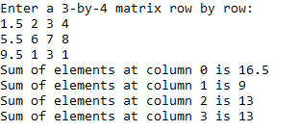

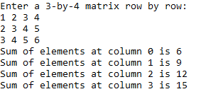

**3 – Matrix of Temperatures**

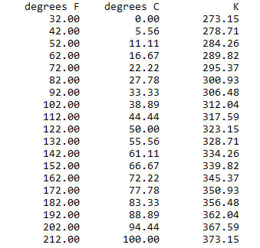

**4 – Vector Class**

